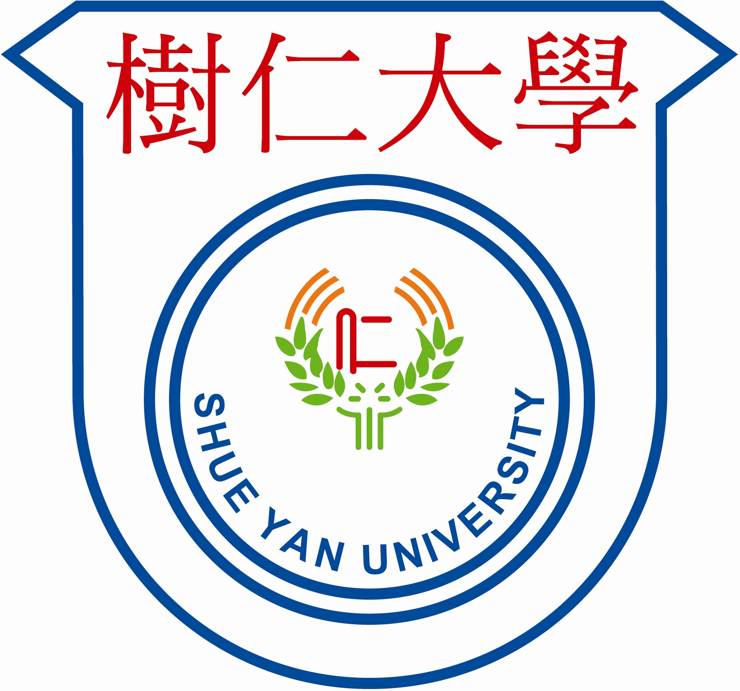
For University use only
Application No.
Interview Invitation
Interview Declined
Remarks

HONG KONG SHUE YAN UNIVERSITY
MASTER OF SOCIAL SCIENCES IN COUNSELLING PSYCHOLOGY

APPLICATION FOR ADMISSION (2023-2024)

1 | This form should be completed in English and in BLOCK LETTERS unless otherwise specified. | Photo
2 | Please complete the form, sign and affix one photo, then submit with your supporting documents and application fee to the Postgraduate Admission office, Master of Social Sciences in Counselling Psychology programme, Department of Counselling and Psychology, Hong Kong Shue Yan University at 10 Wai Tsui Crescent, Braemar Hill, North Point, Hong Kong. | Photo
3 | For enquiries, please contact Admission office by phone at (852) 2104 8270 or via email at mcounpsy@hksyu.edu | Photo

Application For (Please tick) : □ (Full –Time) □ (Part-Time)

A. Personal Information
Name |  |  |  |  | _______________ ____________________________________________________  (Chinese) (English)(Surname) (Given Name) |  |  |  |  |  |  |  |  |  |  |  |  |  |  |  |  |  |  |  | Sex
Age |  |  |  |  |  |  |  | Date of Birth | DD MM YYYY |  |  |  |  |  |  |  |  | Place of Birth
HKID /  Passport No. |  |  |  |  |  |  |  |  | Telephone
 |  |  |  |  |  |  |  |  | Mobile |  |  |  |  | Home |  |  |  |  |  |  | Office
Marital Status |  |  |  |  | Please tick:  □Single □Married □ Divorced □Widowed |  |  |  |  |  |  |  |  |  | Nationality
Email Address |  |  |  |  | (BLOCK letters) |  |  |  |  |  |  |  |  |  | Permanent Hong Kong Resident |  |  |  |  | □ |  | Yes |  | □ |  |  | No
 |  |  |  |  |  |  |  |  |  |  |  |  |  |  |  |  |  |  |  | If “No”, see Note 1
Correspondence Address |  |  |  |  | (Chinese)
 |  |  |  |  | (English)
Please specify whether you need special arrangement for taking the examination/attending an interview : □ Yes □ No

If Yes, specify the arrangement required ________________________________________________________________________
B. Post-Secondary Education (please first list the most recent education)
Period of Attendance |  |  |  |  | Name of Institution  (please state the City/Country of study) |  |  |  |  |  |  |  | Qualification Awarded/to be awarded  (major & minor) |  |  |  |  |  | Mode of Attendance (e.g. Full-time/Part-time on Campus, Distance Learning, etc.) |  |  |  |  |  | Graduation GPA / Classification of Honours
From |  | To
Please indicate by a tick ☑ which of the following courses you have taken in the psychology degree or postgraduate qualification in psychology programme :
□ Cognitive Psychology □ Perception □ Learning □ Memory
□ Biological Psychology □ Physiological Psychology
□ Developmental Psychology □ Child Psychology
□ Personality □ Individual Differences
□ History of Psychology □ Contemporary Issues in Psychology
□ Social Psychology
□ Research Methods in Psychology

C. Other Professional Qualifications (please first list the most recent qualification)
Year Awarded |  |  |  | Qualification Awarded |  |  |  |  |  |  |  |  |  |  |  |  | Awarding Institute
D. Work Experience (please first list the most recent experience)
Period of Employment |  |  |  |  |  | Name of Employer |  |  |  |  |  |  |  |  |  |  | Job Position
From |  |  | To
E. Community Service Experience (please first list the most recent experience)
Period of Service |  |  |  |  |  | Name of Agency/organisation |  |  |  |  |  |  |  |  |  |  | Responsibilities
From |  |  | To
F. English Language Proficiency of Local and Overseas Applicants (English is a not the first language of applicant)
Please tick the test(s) that you have taken |  |  |  |  |  |  |  |  |  |  | Year taken |  | Results (Please submit a photocopy of the report)
_____ TOEFL  _____ IELTS  _____ Other: ____________________ |  |  |  |  |  |  |  |  |  |  | ____________  ____________  ____________ |  | ______________________  ______________________  ______________________
G. References (please provide two references)
Name |  |  |  |  |  |  | Position |  |  | Work Address |  |  |  |  |  | Email Address |  |  |  |  |  |  | Telephone
1.
2.
- Postgraduate Research Scholarship (Full-time postgraduate programmes’ applicants only. Please refer the scholarship criteria and eligibility requirements from the programme’s website.)
□ I am a full time applicant and would like to be considered for the Postgraduate Research Scholarship.
If you have completed a significant research project during your tertiary education, please fill in the following information:
Type of research:
Title:
*Please submit a copy of project together with your application.
- Declaration
I declare that the information given in support of my application is accurate and complete. I understand that any false information will disqualify my application for admission and enrolment in the Hong Kong Shue Yan University, and that any fees paid will not be refunded.

I authorise the Hong Kong Shue Yan University to use my personal data (including photocopies submitted) in this form for all types of processing relevant to my application.

I agree with the contents of the notes below and statement on collection of personal data.

Signature of Applicant |  |  |  |  |  |  |  |  |  |  |  | Date of Application
- Notes
- To study in Hong Kong, all non-local applicants are required to obtain a student visa issued by the Immigration Department of the HKSAR Government, except for those admitted to Hong Kong as dependants, who do not need prior approval before taking up full-time and part-time studies. Non-local applicants issued with a valid employment visa also do not need prior approval to pursue part-time studies. It is the responsibility of individual applicants to make appropriate visa arrangement.
- If you are a graduate of the current academic year, please provide the course information (course code and title) to be completed which has not been printed out in your submitted transcript on a separate sheet.
- Application fees paid are not refundable.
- Graduates of HKSYU are not required to request a transcript from the Registry. Copies of past results will suffice.
- For top-up degree holders, transcripts of sub-degree programme should also be provided.

- Statement on Collection of Personal Data
- The personal data provided in this form will be used for processing your application for admission, and for registration,
academic and administrative communication, research, statistical and marketing purposes. The data will be solely handled by HKSYU staff.
2. When the processing and consideration of all the applications for the programme has been completed: (a) the application
papers of unsuccessful candidates will be destroyed, unless otherwise specified and (b) the application papers of successful candidates will serve as part of the applicant’s official student’s records and will be handled by HKSYU staff in relation to the stated purposes. In all circumstances, please be assured that any personal information you provide will be kept strictly confidential.
3. From time to time, the University will send the latest updates and promotional materials to applicants/students and alumni regarding the availability of programmes, seminars and courses.

If you DO NOT WISH to receive our latest updates and promotional materials as stated above, please check this box □

- Checklist
 | A photocopy of HKID Card/Passport
 | An application fee of HK$200 by crossed-cheque to “HONG KONG SHUE YAN UNIVERSITY”
 | Official Transcripts from post-secondary institutions/universities attended
 | A photocopy of each degree certificate obtained
 | A photocopy of each professional qualification obtained
 | Autobiographical Statement
 | 2 signed and sealed Referee Reports
 | Programme Promotion Survey

HONG KONG SHUE YAN UNIVERSITY
MASTER OF SOCIAL SCIENCESE IN COUNSELLING PSYCHOLOGY

Autobiograhical Statement

Name: (Chinese) ______________________________

(English) (Surname) ___________________ (Given Name) _________________________________

Please type or print clearly an autobiographical statement about yourself of no more than 1500 words in English including:
- your personal background
- what makes you suited for counselling psychology
- how you want to use this degree in the future
- why the admission committee should select you
(Please attach additional sheets if necessary.)

Applicant's Signature :______________________________________ Date : ___________________________________________

HONG KONG SHUE YAN UNIVERSITY
MASTER OF SOCIAL SCIENCES IN COUNSELLING PSYCHOLOGY

PROGRAMME PROMOTION SURVEY

Age: _______

Sex: ______

Highest Degree Earned: _______________________________________________________________________

How did you learn about our master’s degree programme in counselling psychology?

___ Website (please specify ___________________________________________________________ _ )
___ Brochure/Poster (please specify location _______________________________________________ )
___ Referred by friends/colleagues
___ Referred by HKSYU faculty
___ Referred by HKSYU alumni
___ Newspaper (please specify __________________________________________________________ )
___ Other (please specify ______________________________________________________________ )

Have you attended the Information Seminar held by the University? _____Yes _____No

Thank you for your information!

